National University of Computer and Emerging Sciences Islamabad Programming Fundamentals Lab FALL 2022

### Lab Manual 10

**Repetitions-I (while loop, do…while loop, for loop)**

A loop within another loop is called nested loop. This is how a nested loop looks like:

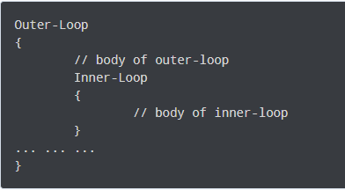

As you can see, the outer loop encloses the inner loop. The inner loop is a part of the outer loop and must start and finish within the body of outer loop. On each iteration of outer loop, the inner loop is executed completely.

# Nested For Loop:

A for loop inside another for loop is called nested for loop.

## Syntax:

for (initialization; condition; increment/decrement)

{

statement(s);

for (initialization; condition; increment/decrement)

{

statement(s);

... ... ...

}

... ... ...

}

## Flowchart of For loop:

## 

## Example:

C++ program to display a pattern with 5 rows and 3 columns.

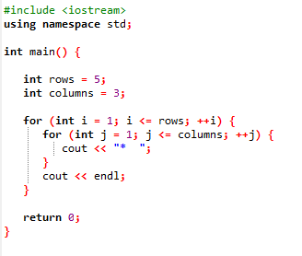

## Output:

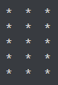

# Nested While Loop:

A While loop inside another while loop is called nested while loop.

## Syntax:

while (condition)

{

statement(s);

while (condition)

{

statement(s);

... ... ...

}

... ... ...

}

## Flowchart of While loop:

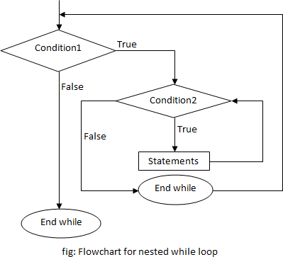

## Example:

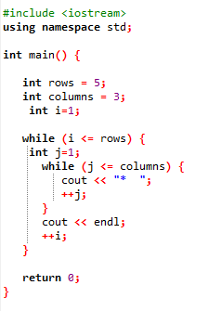

## Output:



# Lab Tasks

Problem solving using C++.

# Note: You have to make a Function in each task.

# Problem 01:

Write a CPP Program that produce following pattern using nested loop.

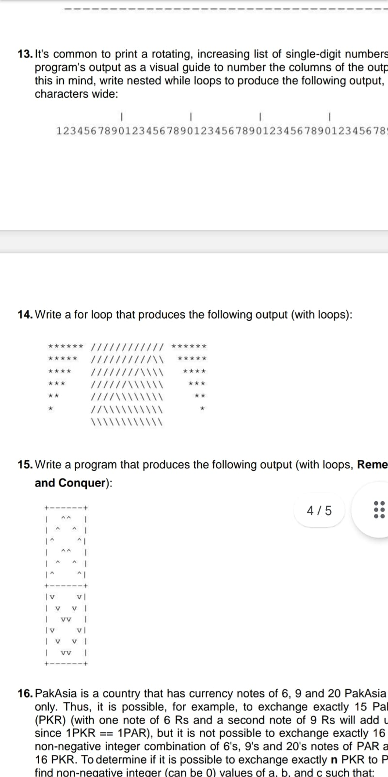

# Problem 02:

Write a C++ program that receives an integer n as input and prints the total number of ones (1s) in the binary representation of n.

**Example:**

Input number: 5

Output: 2

|  |
| --- |
| **Submission Instructions:**   1. Save all .cpp files and screenshot with Question number e.g. Q1.cpp 2. Now create a new folder with name NAME_ROLLNO_LAB11 e.g. XYZ_i22XXXX_LAB10 3. Move all of your .cpp files to this newly created directory and compress it into .zip file. 4. Now you have to submit this zipped file on Google Classroom. |